**#31B: A 117 EMERGENCY COMMUNICATION PLATFORM FOR ABUSE REPORT IN A MOBILE APPLICATION**

Alonzo, Arlene Grace C.

[2018003438@dhvsu.edu.ph](mailto:2018003438@dhvsu.edu.ph)

Dela Cruz, Diane Louise M.

[2018003367@dhvsu.edu.ph](mailto:2018003367@dhvsu.edu.ph)

Belleza, Ram Rainier M.

[2018003704@dhvsu.edu.ph](mailto:2018003704@dhvsu.edu.ph)

Magat, Mharck Stephen P.

[2018003647@dhvsu.edu.ph](mailto:2018003647@dhvsu.edu.ph)

de Leon, Aileen P.

[apdeleon@dhvsu.edu.ph](mailto:apdeleon@dhvsu.edu.ph)

Mañalac, Gerald O.

[2007100820@dhvsu.edu.ph](mailto:2007100820@dhvsu.edu.ph)

Pineda, John Carlo C.

[2018003448@dhvsu.edu.ph](mailto:2018003448@dhvsu.edu.ph)

Soriano, Justine G.

[2018003629@dhvsu.edu.ph](mailto:2018003629@dhvsu.edu.ph)

**ABSTRACT**

The proposed study aims to establish an idea of a free communication platform for the victims of abuse, that is user-friendly, with much better assistance and immediate response, with the help and support from the local authorities and social services. It would also be a big help to promote awareness to the local residents. Quantitative descriptive type of approach was used, which served as a helpful way of reporting abuse cases through a mobile application, and also to gather data regarding the abuse cases in the target locale. The researchers used agile methodology to emphasize the collaboration of the group, user feedback, continuous improvement, and the adapting capacity to changing activity. Surveys were conducted to test the functional stability, reliability, usability, performance efficiency and security of the study. The survey result showed the difference between the proposed system and the existing system. It was found that the proposed system has a greater impact and advantage to the respondents with an average mean of 3.73 (Interpretation of ***Strongly Agree***) compared to the existing system with an average mean of 2.52 (Interpretation of ***Agree***). The result proved that the application was able to provide an additional way of submitting a complaint report to the authorities and useful information to the respondents in the community.

indicate the most impactful results (in pre-study survey and or system evaluation) of the study and its implication to highlight the importance of this study.

*Keywords: Domestic Abuse, Complaint, Mobile Application, VAWC*

**Introduction**

Abuse is defined as an act of violence and/or maltreatment towards a person or things to gain benefit. According to the Philippine Statistics Authority's (PSA) 2017 National Demographic and Health Survey, one (1) out of every four (4) Filipino women aged 15 to 49 has experienced physical, emotional, economic or sexual abuse from their husband or partner, or any family member. Over 16 million Filipino poorer women were more vulnerable to assault since they couldn't protect themselves, according to the survey. One of the Philippine laws concerning abuse is the Republic Act 9262: the Anti-Violence Against Women and their Children Act of 2004. Devised to reduce violence against women and their children (VAWC) perpetrated by their husband, intimate partners, or member of the family.

Domestic abuse occurs in homes and with the established pandemic lockdown it shows that victims are more likely to have increased risk of the abusers. Stay-at-home policies like school closures, have restricted access to traditional sources of assistance for families and individuals, such as friends, extended families, and professionals (World Health Organization, 2020). Not all lockdowns are great for the victims of domestic abuse, since lockdowns constrain their movements physically from the help, they need that is mostly available outside.

An article published by Ranada (2020) stated that it is more difficult for a victim-survivor to report their situations particularly if they are located in an area with restricted mobility and absence of public transit. Also, according to the Commission on Human Rights "Women and children who experience abuse are trapped inside their homes with their abusers, and have nowhere to go. Most of these women are not able to seek help due to fear of being overheard by their abusive partners or stopped from leaving home". The question lies on what the other available platforms where victims/witnesses can place their complaints in a confidential environment are. Although there are campaigns about abuse protections and hotlines to raise awareness before and during the pandemic, a lot of people are still unmindful of it. The following problems gave the researchers an idea of what the study could do: How knowledgeable are the victims regarding the appropriate emergency hotlines; How difficult is it for the victim to reach out and report their difficult or abused situation to the emergency hotlines and office’s desks; What to do when the victim is in that difficult or dangerous situation; How to know what and who are the possible causes of abuse in the area; How to file for an initial abuse report of an offender or abuser without actually calling for the authorities. As seen on the data gathered, the researchers decided to propose a study in the field of data analytics. Data analytics is increasingly being employed with the help of specialized tools and software (Steadman, 2020). As it brings a faster way of discovering the current trends and its accurate solutions. State other noteworthy studies/literatures that has direct impact to your study. Let’s say for example, which of your literatures/studies concluded how software applications directly help in increasing consciousness?

Having and creating an Awareness Module found in the application iJuanaHelpMo educates victims that can help to know their own rights, what resources they can find, and support that is applicable to any Filipinos regarding violence and abuse they experience inside their homes. In this application module, victims can read related laws and rights related to Violence Against Women and Children. They can educate themselves as it serves a series of references that is linked to their current state (Balahadia & Mortel, 2020).

With this, the researchers decided to propose a study entitled ***#31b: A 117 Emergency Communication Platform for Abuse Report in a Mobile Application***, an application that would be able to help decrease the escalating rate of domestic abuse and variety of physical, mental, economic and sexual abuse that is happening in the Philippines. Through the help of data analytics, it will be easier to identify the places that need monitoring and immediate assistance, regarding the abuse cases happening in certain local areas. It would also be a big help to promote awareness to local residents.

The proposed study aims to establish an idea of a free communication platform for the victims and witnesses of abuse that is user-friendly, with better assistance, immediate response, and with the help and support from the local authorities and social services.

**Method**

The researchers used a quantitative descriptive type of approach because the purpose of the proposed study is to serve as a helpful way of reporting abuse cases through a mobile application and also to gather data regarding the abuse cases in the target locale.

The research instruments were in the form of a self-made survey questionnaire through Google Forms and Interview. All questions were made to be answerable by Likert scale. There were three (3) types of questionnaires: for victim or witness, for police and for ordinary Pampanga residents. The questionnaires were distributed to various respondents of the locale. The researchers conducted a virtual interview with a former Women and Children Protection Desk Officer from Lubao, Pampanga. The objective of the interview was to know the current process of filing a complaint against an abuser, and the basic information needed for the complaint. The characteristics of the respondents are as follows; thirteen (13) years old and above, residing in the municipalities located in the 2nd District of Pampanga (Floridablanca, Guagua, Lubao, Porac, Santa Rita, and Sasmuan), victims of abuse, witnesses of abuse, male, female or LGBTQ+.

The researchers used agile methodology for software development of the application. The agile model emphasizes the collaboration of the group, user feedback, continuous improvement, and the adapting capacity to changing activity. The stages of the methodology that the researchers used are initial planning, planning, requirements, analysis and design, development and testing, and evaluation.

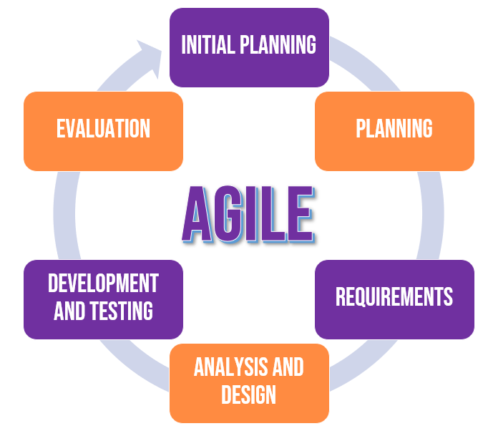

*Figure 1 Agile Systems Methodology*

Starting from the initial planning, the researchers collected data from different related literature, studies, and existing applications related to crime about abuse. A representative from PNP Women Desk was interviewed as part of the study. The researchers were able to gain greater understanding of the demands of the application's users and some of the victims who have been reported with the support of official government input. Browsing the materials for the mobile application's development was also done. Then planning, the researchers evaluated the collected information in order to create all of the possible plans and objectives, as well as the application's concept and target users. Requirements, in order to complete all of the study's requirements. The researchers organized the data with the use of some hardware such as personal computers, mobile phones, and various software in order to construct and analyze the study. In Analysis and Design, using different methods such as Data Flow Diagram (DFD) and Entity-Relationship Diagram (ERD), the researchers designed and conceptualized the layout and techniques of the mobile application in this phase. The flow of the #31b mobile application was analyzed using the DFD and ERD based on its function. Development and Testing, the researchers began developing the application at this point, based on the ideas generated during the analysis and design, as well as the data acquired and the needs. The testing stage of the mobile application and admin website will verify if both are functioning properly and if it contains any possible errors or bugs. A variety of te sts will be carried out to confirm that all relevant features are present.

Lastly, International Organization for Standardization (ISO) / International Electrotechnical Commission (IEC) 25010 was used as a reference in crafting the evaluation for the system to determine the user’s likelihood to accept the study, this is in terms of functional stability, performance efficiency, usability, reliability, and security of the #31b mobile application.

The researchers used likert scale to analyze the statistical data from the survey questionnaires and the evaluation tool. The researchers chose a four-point scale that will be used in the survey questionnaires and evaluation tool: 1 – Strongly disagree: 2 – Disagree: 3 –Agree: 4 –Strongly Agree.The gathered data was analyzed using the weighted mean and interpreted.

|  |  |  |
| --- | --- | --- |
| Point | Scale Range | Interpretation |
| 4 | 3.26 – 4.00 | Strongly Agree |
| 3 | 2.51 – 3.25 | Agree |
| 2 | 1.76 – 2.50 | Disagree |
| 1 | 1.00 – 1.75 | Strongly Disagree |

**Results and Discussion**

The respondents of the study were the Pampanga residents, victims or witnesses and police officers with a total number of 377 respondents. The evaluation form determines the satisfaction of the respondents with the functional stability, reliability, usability, performance efficiency and security of the existing and proposed system.

**Table 1. Evaluation of the Functional Stability of the Existing System.**

|  |  |  |  |  |  |  |  |
| --- | --- | --- | --- | --- | --- | --- | --- |
| **Indicators** | **4** | **3** | **2** | **1** | **WV** | **WM** | **I** |
| **Completeness**  The set of functions covers all the specified tasks and user objectives | **18**  72 | **165**  495 | **174**  348 | **20**  20 | **377**  935 | **2.48** | **Disagree** |
| **Correctness**  The function provides the correct results with the needed degree of precision | **46**  184 | **142**  426 | **151**  302 | **38**  38 | **377**  950 | **2.52** | **Agree** |
| **Appropriateness**  The function facilitate**s** the accomplishment of specified tasks and objectives | **38**  152 | **173**  519 | **124**  248 | **42**  42 | **377**  961 | **2.55** | **Agree** |
| **Average Weighted Mean = 2.52 (Agree)** | | | | | | | |

The data representation indicated that the functional stability of the existing system is efficient enough to sustain a stable abuse case reporting platform. Stipulating an average mean computation of **2.52**, with the result interpretation level equivalent to **“Agree”** with reference to the functional stability of the said system. And having an average weighted mean as mentioned, this specifies that the existing system requires additional improvement with the actual service functionality, focusing on the overall completeness of the existing system.

**Table 2. Evaluation of the Reliability of the Existing System**

|  |  |  |  |  |  |  |  |
| --- | --- | --- | --- | --- | --- | --- | --- |
| **Indicators** | **4** | **3** | **2** | **1** | **WV** | **WM** | **I** |
| **Maturity**  The   system meets for reliability under normal operation | **32**  128 | **134**  402 | **126**  252 | **85**  85 | **377**  867 | **2.30** | **Disagree** |
| **Availability**  The   system is operational and accessible when require for use | **49**  196 | **144**  432 | **147**  294 | **37**  37 | **377**  959 | **2.54** | **Agree** |
| **Average Weighted Mean = 2.42 (Disagree)** | | | | | | | |

As shown in table 2, the data representation indicated that the reliability of the existing system is efficient enough to sustain a stable abuse case reporting platform. Stipulating an average mean computation of **2.42**, with the result interpretation level equivalent to **“Disagree”** with reference to the reliability of the said system. And having an average weighted mean as mentioned, this specifies that the existing system needed to improve the reliability function it performs, how the system must be highly operational and accessible at all times, requirements that the proposed system will resolve.

**Table 3.   Evaluation of the Usability of the Existing System**

|  |  |  |  |  |  |  |  |
| --- | --- | --- | --- | --- | --- | --- | --- |
| **Indicators** | **4** | **3** | **2** | **1** | **WV** | **WM** | **I** |
| **Appropriateness Recognizability**  User can recognize whether the   system is appropriate for their needs | **46**  184 | **149**  447 | **139**  278 | **43**  43 | **377**  **952** | **2.53** | **Agree** |
| **Operability**  The   system is easy to operate, control and appropriate to use | **42**  168 | **465**  495 | **125**  250 | **77**  77 | **377**  **990** | **2.63** | **Agree** |
| **User Interface Aesthetics**  A user interface enables pleasing and satisfying interactions for the user | **48**  192 | **155**  465 | **112**  224 | **62**  62 | **377**  **943** | **2.50** | **Disagree** |
| **Accessibility**  The   system can be used by people with the widest range of characteristics and capabilities to achieve a specified goal in a specified context of use. | **43**  172 | **116**  348 | **166**  332 | **52**  52 | **377**  **904** | **2.40** | **Disagree** |
| **Average Weighted Mean = 2.52 (Agree)** | | | | | | | |

As shown in table 3, the data representation indicated that the usability of the existing system is efficient enough to sustain a stable abuse case reporting platform. Stipulating an average mean computation of **2.52**, with the result interpretation level equivalent to **“Agree”** with reference to the usability of the said system. And having an average weighted mean as mentioned, this specifies that the existing system requires additional improvement with the usability function it performs. The researchers must provide a much capable, satisfying, and easy to use system, that the major usability goal is to serve the people or users at its finest, that the proposed system will resolve.

**Table 4. Evaluation of the Performance Efficiency of the Existing System**

|  |  |  |  |  |  |  |  |
| --- | --- | --- | --- | --- | --- | --- | --- |
| **Indicators** | **4** | **3** | **2** | **1** | **WV** | **WM** | **I** |
| **Time- behavior**  The response and processing times and throughout rates of the   system, when performing its functions meets the requirements | **39**  156 | **166**  498 | **109**  218 | **63**  63 | **377**  935 | **2.48** | **Disagree** |
| **Average Weighted Mean = 2.48 (Disagree)** | | | | | | | |

As shown in table 4, the data representation indicated that the performance efficiency of the existing system is efficient enough to sustain an efficient abuse case reporting platform. Stipulating an average mean computation of **2.48**, with the result interpretation level equivalent to **“Disagree”** with reference to the performance efficiency of the said system. And having an average weighted mean as mentioned, this specifies that the existing system requires additional improvement with the performance efficiency functionality. Assessing the performance in time-behavior, on the quickness of response together with the efficiency of the processing, which will be resolved by the proposed system.

**Table 5.  Evaluation of the Security of the Existing System**

|  |  |  |  |  |  |  |  |
| --- | --- | --- | --- | --- | --- | --- | --- |
| **Indicators** | **4** | **3** | **2** | **1** | **WV** | **WM** | **I** |
| **Confidentiality**  The   system ensures that data are accessible only to those authorized to have access | **71**  284 | **154**  441 | **114**  228 | **45**  45 | **377**  **998** | **2.65** | **Agree** |
| **Integrity**  The   system prevents unauthorized access to, or modification of, computer programs or data | **74**  296 | **161**  483 | **79**  158 | **63**  63 | **377**  **1000** | **2.65** | **Agree** |
| **Average Weighted Mean = 2.65 (Agree)** | | | | | | | |

As shown in table 5, the data representation indicated that the security of the existing system is efficient enough to sustain a secured abuse cases reporting platform. Stipulating an average mean computation of **2.65**, with the result interpretation level equivalent to **“Agree”** with reference to the security of the said system. And having an average weighted mean as mentioned, this specifies that the existing system requires additional improvement with the security function it provides. The system needs to modify or upgrade its confidentiality and integrity, the authorization, roles, and its open accessibility to people or users, due to its open source demanding platform such as the written application for the complaint reports that can be a deficiency as an abuse complaining platform, which will be resolved by the proposed system.

**Table 6.  Evaluation of the Functional Stability of the Proposed System**

|  |  |  |  |  |  |  |  |
| --- | --- | --- | --- | --- | --- | --- | --- |
| **Indicators** | **4** | **3** | **2** | **1** | **WV** | **WM** | **I** |
| **Completeness**  The set of functions covers all the specified tasks and user objectives | **275**  1100 | **102**  306 | **0** | **0** | **377**  1406 | **3.73** | **Strongly Agree** |
| **Correctness**  The function provides the correct results with the needed degree of precision | **262**  1048 | **115**  345 | **0** | **0** | **377**  1393 | **3.69** | **Strongly Agree** |
| **Appropriateness**  The function facilitate**s** the accomplishment of specified tasks and objectives | **277**  1108 | **98**  294 | **0** | **0** | **377**  1402 | **3.72** | **Strongly Agree** |
| **Average Weighted Mean = 3.71 (Strongly Agree)** | | | | | | | |

As shown in table 6, the data representation indicated that the functional stability of the proposed system is much more effective and stable for an abuse case reporting platform. Stipulating an average mean computation of **3.71**, with the result interpretation level equivalent to **“Strongly Agree”** with reference to the functional stability of the said system. And having an average weighted mean as aforementioned, specifies that the proposed system is effective in terms of functional stability.

**Table 7. Evaluation of the Reliability of the Proposed System**

|  |  |  |  |  |  |  |  |
| --- | --- | --- | --- | --- | --- | --- | --- |
| **Indicators** | **4** | **3** | **2** | **1** | **WV** | **WM** | **I** |
| **Maturity**  The system meets for reliability under normal operation | **252**  1004 | **117**  351 | **9**  18 | **0** | **377**  1373 | **3.64** | **Strongly Agree** |
| **Availability**  The   system is operational and accessible when require for use | **280**  1120 | **93**  279 | **4**  8 | **0** | **377**  1407 | **3.73** | **Strongly Agree** |
| **Average Weighted Mean = 3.69 (Strongly Agree)** | | | | | | | |

As shown in table 7, the data representation indicated that the reliability of the proposed system is much more effective and reliable for an abuse case reporting platform. Stipulating an average mean computation of **3.69**, with the result interpretation level equivalent to **“Strongly Agree”** with reference to the functional stability of the said system. And having an average weighted mean as aforementioned, specifies that the proposed system fulfilled the additional improvement needed of the existing system, indicating that the system is highly operational, accessible and available at all times.

**Table 8.  Evaluation of the Usability of the Proposed System**

|  |  |  |  |  |  |  |  |
| --- | --- | --- | --- | --- | --- | --- | --- |
| **Indicators** | **4** | **3** | **2** | **1** | **WV** | **WM** | **I** |
| **Appropriateness Recognizability**  User can recognize whether the   system is appropriate for their needs | **284**  1132 | **90**  270 | **4**  8 | **0** | **377**  1407 | **3.73** | **Strongly Agree** |
| **Operability**  The   system is easy to operate, control and appropriate to use | **298**  1192 | **79**  237 | **0** | **0** | **377**  (429 | **3.79** | **Strongly Agree** |
| **User Interface Aesthetics**  A user interface enables pleasing and satisfying interactions for the user | **314**  1256 | **62**  186 | **0** | **0** | **377**  1442 | **3.82** | **Strongly Agree** |
| **Accessibility**  The   system can be used by people with the widest range of characteristics and capabilities to achieve a specified goal in a specified context of use. | **280**  1120 | **92**  276 | **5**  10 | **0** | **377**  1406 | **3.73** | **Strongly Agree** |
| **Average Weighted Mean = 3.77 (Strongly Agree)** | | | | | | | |

As shown in table 8, the data representation indicated that the usability of the proposed system is much more effective and usable, it can sustain a stable abuse case reporting platform. Stipulating an average mean computation of **3.77**, with the result interpretation level equivalent to **“Strongly Agree”** with reference to the usability of the said system. And having an average weighted mean as mentioned, this specifies that the proposed system fulfilled the required additional improvement with the usability function it performs. Additional improvements such as information boards and submitting of complaint forms in one application allows the user to easily use the application. Also, a more interesting interface to make the users more engaged in the application and its content.

**Table 9. Evaluation of the Performance Efficiency of the Proposed System**

|  |  |  |  |  |  |  |  |
| --- | --- | --- | --- | --- | --- | --- | --- |
| **Indicators** | **4** | **3** | **2** | **1** | **WV** | **WM** | **I** |
| **Time- behavior**  The response and processing times and throughout rates of the   system, when performing its functions meets the requirements | **273**  1092 | **97**  291 | **7**  14 | **0** | **377**  1397 | **3.70** | **Strongly Agree** |
| **Average Weighted Mean = 3.70 (Strongly Agree)** | | | | | | | |

As shown in table 9, the data representation indicated that the performance efficiency of the proposed system is much more effective for an abuse case reporting platform. Stipulating an average mean computation of **3.70**, with the result interpretation level equivalent to **“Strongly Agree”** with reference to the performance efficiency of the said system. And having an average weighted mean as mentioned, this specifies that the proposed system fulfilled the required additional improvement with the performance efficiency function it performs. Indicating assessed time-behavior, with quick response together with the high efficiency data processing.

**Table 13.  Evaluation of the Security of the Proposed System**

|  |  |  |  |  |  |  |  |
| --- | --- | --- | --- | --- | --- | --- | --- |
| **Indicators** | **4** | **3** | **2** | **1** | **WV** | **WM** | **I** |
| **Confidentiality**  The   system ensures that data are accessible only to those authorized to have access | **308**  1228 | **64**  192 | **6**  12 | **0** | **377** 1432 | **3.79** | **Strongly Agree** |
| **Integrity**  The   system prevents unauthorized access to, or modification of, computer programs or data | **286**  1144 | **87**  261 | **4**  8 | **0** | **377**  1413 | **3.74** | **Strongly Agree** |
| **Average Weighted Mean = 3.77 (Strongly Agree)** | | | | | | | |

As shown in table 13, the data representation indicated that the performance efficiency of the proposed system is much more effective and secured for an abuse cases reporting platform Stipulating an average mean computation of **3.77**, with the result interpretation level equivalent to **“Strongly Agree”** with reference to the security of the said system. And having an average weighted mean as mentioned, this specifies that the proposed system fulfilled the required additional improvement with the security function. The system modified and upgraded the confidentiality and integrity, the authorization, roles, and the secured accessibility of the users.

The following are the screenshots of the proposed application:

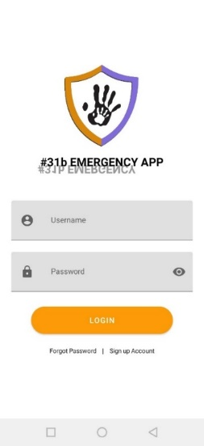 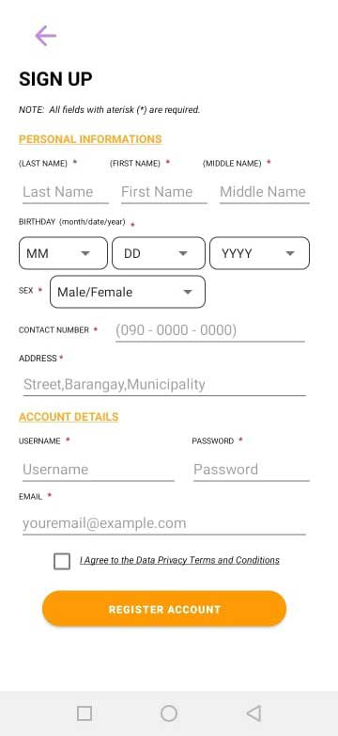

|  |  |
| --- | --- |
| Figure 2. Login Page | Figure 3. Sign Up – Page |

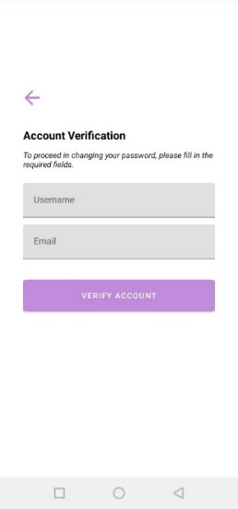 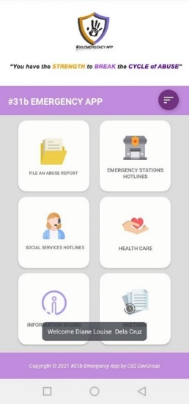

|  |  |
| --- | --- |
| Figure 4. Forgot Password | Figure 5. Dashboard Page |

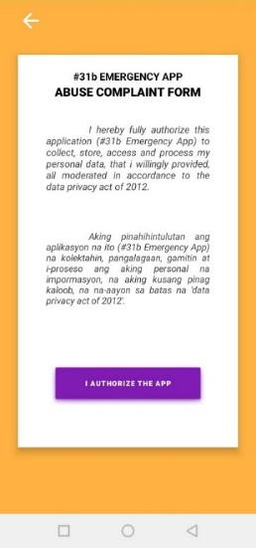 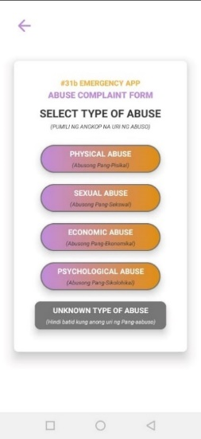

|  |  |
| --- | --- |
| Figure 6. File Abuse Report Page | Figure 7. File Abuse Report Page 2 |

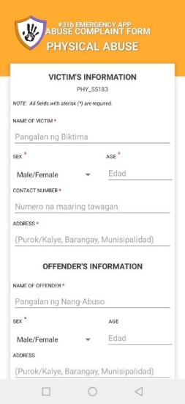 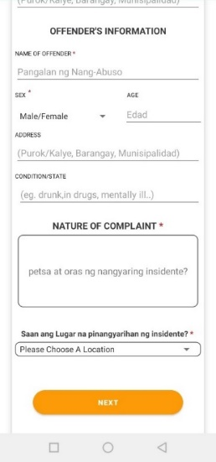

|  |
| --- |
| Figure 8. Complaint Page |

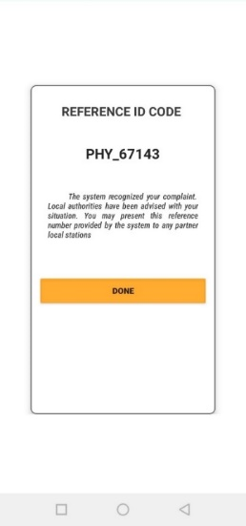 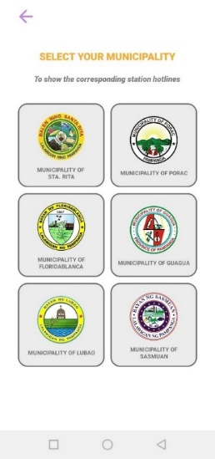

|  |  |
| --- | --- |
| Figure 9. Reference Code Page | Figure 10. Emergency Hotline Page |

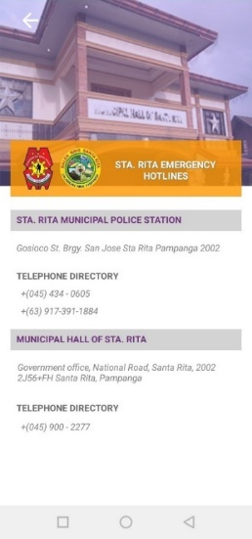 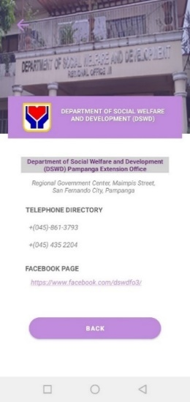

|  |  |
| --- | --- |
| Figure 11. Municipality Page | Figure 12. Social Services Page |

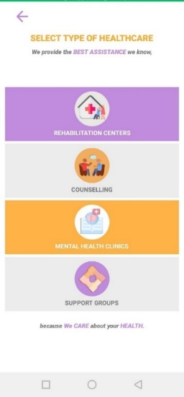 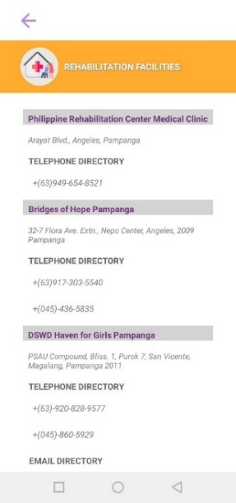

|  |  |
| --- | --- |
| Figure 13. Health Care Page | Figure 14. Rehabilitation Page |

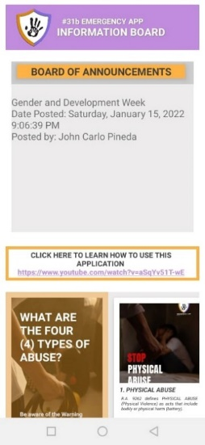 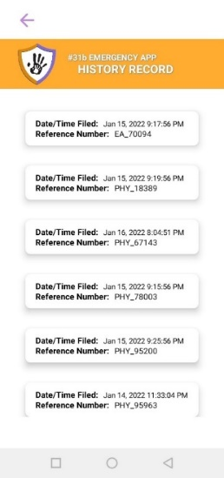

|  |  |
| --- | --- |
| Figure 15. Information Board Page | Figure 16. History Page |

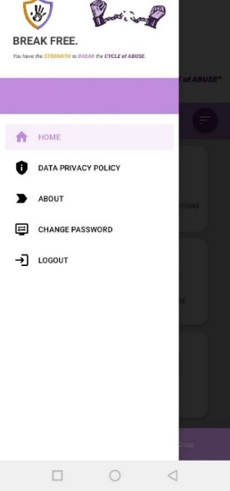 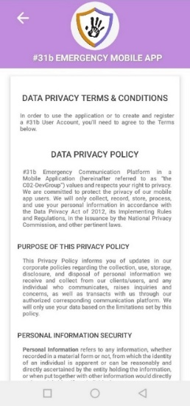

|  |  |
| --- | --- |
| Figure 17. Side Navigation | Figure 18. Data Privacy Terms & Conditions |

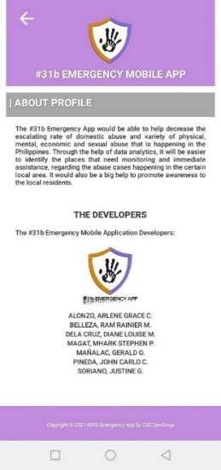 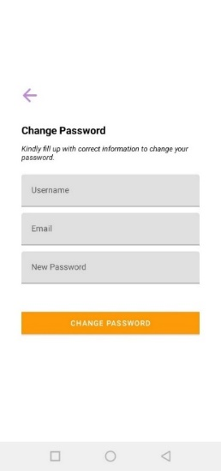

|  |  |
| --- | --- |
| Figure 19. About Page | Figure 20. Change Password Page |

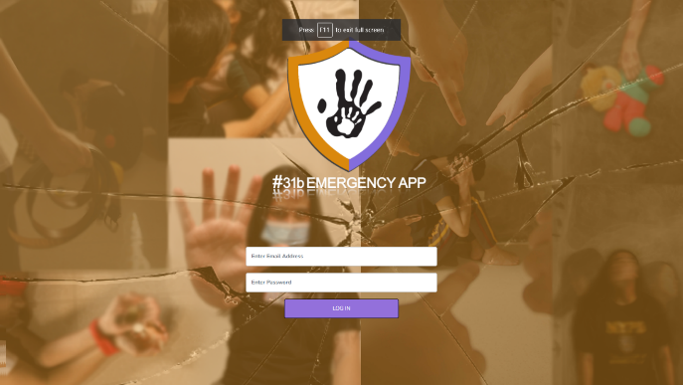

Figure 21. Login Page – SuperAdmin/Admin

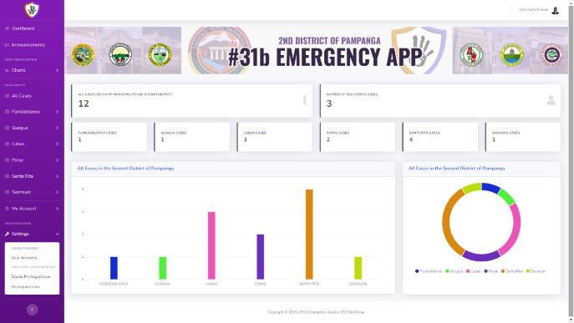

Figure 22. Super Admin Dashboard

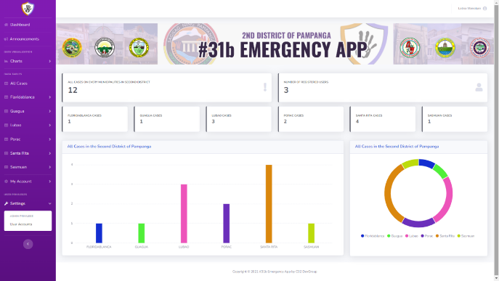

Figure 23. Admin Dashboard

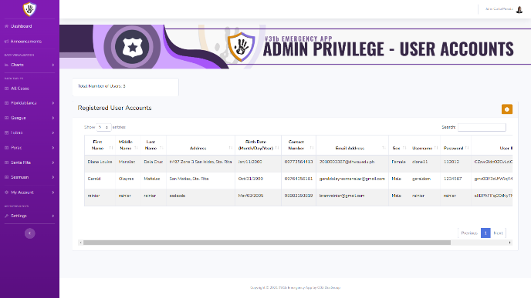

Figure 24. User Accounts Page

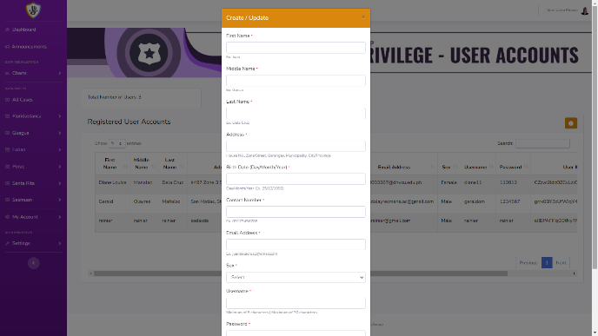

Figure 25. Create User

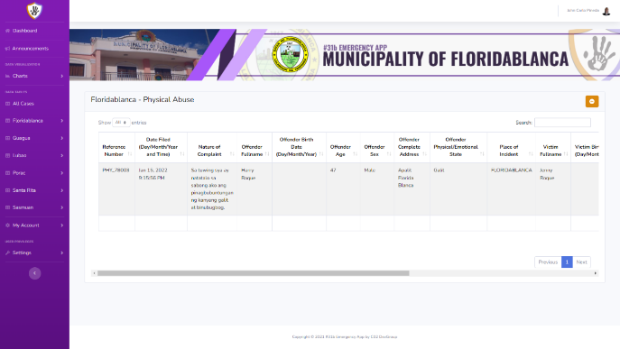

Figure 26. Municipal Data Table

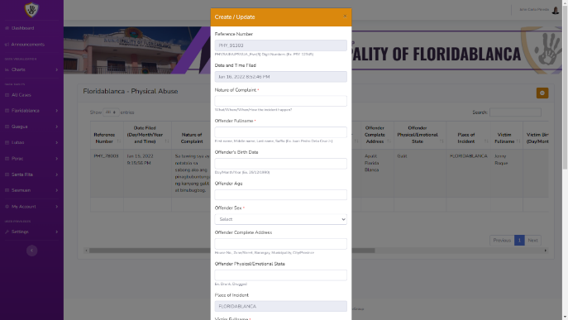

Figure 27. Create Complaint

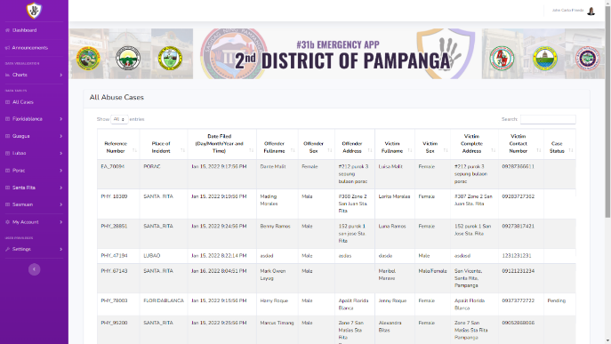

Figure 28. All Abuse Cases Table Page

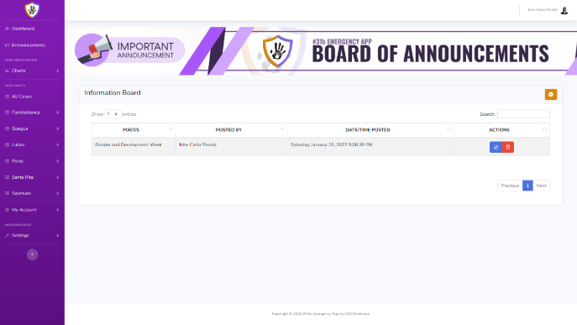

Figure 29. Board of Announcements

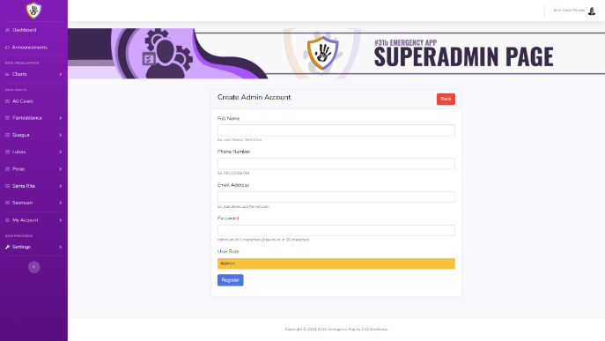

Figure 30. Create Admin age

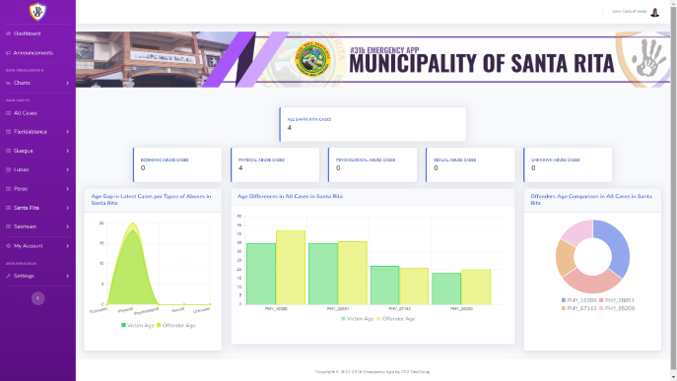

Figure 31. Municipal Chart

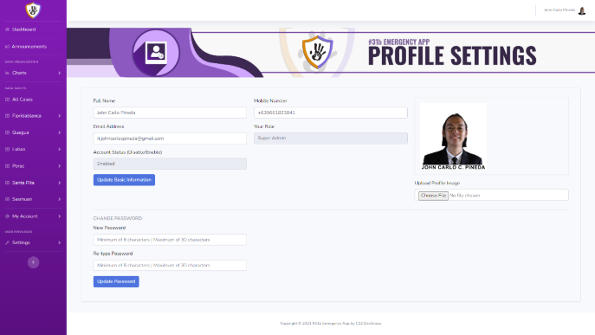

Figure 32. Profile Settings Page

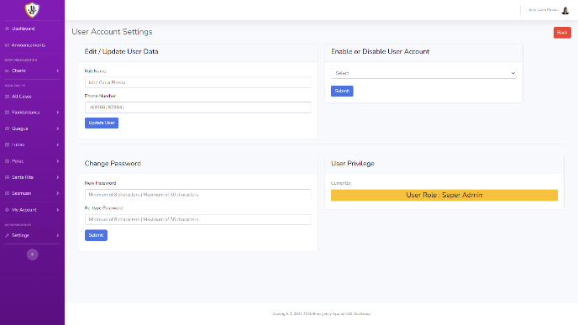

Figure 33. User Account Settings Page

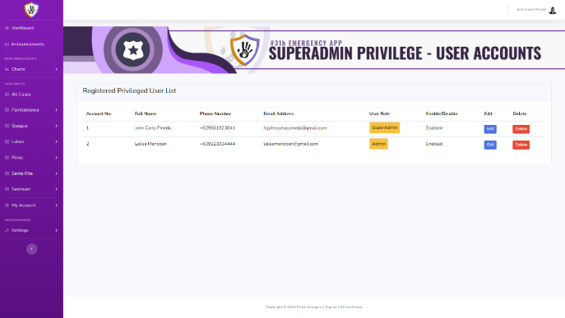

Figure 34. Privilege User Accounts

**CONCLUSION**

The overall study was concluded successful as the aim and objective identify directly which of the aims or goals were met of the #31b: A 117 Emergency Communication Platform for Abuse Report in a Mobile Application was met successfully. The application was able to provide an additional way of submitting a complaint report to the authorities. Also, by providing helpful information such as emergency hotlines, stations, institutions and facilities for the victims. Also, an information board that also tackles on how to identify if a person is being abused and what are the ways to report the abuse and stop it. The visual aesthetics of the application also helped in giving interest to the users. All of these are utilized in one application that will give benefit to the users. What particular result(s) that has direct impact to the community? In the evaluation survey, the respondents found out that they Strongly Agree in terms of security with an average mean of 3.77%, usability with an average mean of 3.77% and functional stability with an average mean of 3.71% elaborate further by synthesizing the meaning of this percentage results. This result signifies that the proposed system has a greater impact and advantage to the users than the existing system in terms of functional stability, reliability, usability, performance efficiency and security. Therefore, the researchers concluded that the results are in line with the overall quality of the proposed system.

**RECOMMENDATION**

How do you recommend to implement this study in the community? In the identified weaknesses of the study, how should the developers/community implement this tool? The researchers recommend to implement the study in the community by promoting the application through the use of social media and local authorities, by providing enough information on how useful the application is. The researchers recommend the following improvements and additional upgrade features for the next researchers that would like to take the similar study. Firstly, the adjusting and enhancement of the administrator’s website and mobile application appearance, adding more functionality for data visualization, additional language support for local users, and a new user sign-up authentication feature using the National Identification number issued by the Philippine Statistics Authority (PSA). Secondly, is to use a different approach or System Development Life Cycle, that could possibly help the future researchers to achieve greater outcomes. Introduce this statement better. Lastly, the use of multi-platform application development can address the accessibility and usability to different mobile operating systems, to accommodate and help more users. The respondents found the application useful despite of its shortcomings. The process of improving the application features continues as it is being implemented in the community

**REFERENCES**

1. (2021). Retrieved from Philippine Statistics Authority. : https://psa.gov.ph/classification/psgc/?q=psgc%2Fcitimuni%2F035400000
2. Abdullah, J. e. (2020). An Application of the Theory of Planned Behavior in Predicting Child Abuse Reporting Intention of Malaysian Society. *KnE Social Sciences,*, 225-238.
3. Abellán, E. (2020, February 6). *What’s the Agile methodology and how can it benefit your enterprise?* . Retrieved from Digital Marketing Agency and Consultancy Online | WAM. : https://www.wearemarketing.com/blog/what-is-the-agile-methodology-and-what-benefits-does-it-have-for-your-company.html
4. Atmowardoyo, H. (2018). Research Methods in TEFL Studies: Descriptive Research, Case Study, Error Analysis, and R & D. *Journal of Language Teaching and Research, Vol. 9, No. 1*, 197-204.
5. Balahadia, F., & Mortel, Z. (2020). iJuanaHelpMo: Web and Mobile Application for Reporting Violence: A Framework for Developing Violence Against Women Application. *Asia Pacific Journal of Multidisciplinary Research, Volume 8, No. 3*, 30-36.
6. Bertram, D. (2017, May). *Likert Scales.* Retrieved from Welcome to Digilib UIN Sunan Ampel Surabaya - Digilib UIN Sunan Ampel Surabaya. : https://digilib.uinsby.ac.id/750/6/Bab%203.pdf
7. Blog, F. (2020, November 3). *Survey research: Types, examples & methods*. Retrieved from Create Free Online Forms & Surveys in 2 Mins | Formplus.: https://www.formpl.us/blog/survey-research
8. Britton, J. (2021, May 6). *What is ISO 25010?* Retrieved from Perforce Software. : https://www.perforce.com/blog/qac/what-is-iso-25010
9. Calleja, J. (2020, October 9). *Domestic violence all the rage in Philippine lockdown*. Retrieved from ucanews.com: https://www.ucanews.com/news/domestic-violence-all-the-rage-in-philippine-lockdown/89821
10. Campbell, J. (2020, July 6). *Coronavirus and Domestic Violence: What You Should Know.* Retrieved from Johns Hopkins Medicine. : https://www.hopkinsmedicine.org/health/conditions-and-diseases/coronavirus/coronavirus-and-domestic-violence-what-you-should-know
11. Ceccato, V. (2019). Eyes and Apps on the Streets: From Surveillance to Sousveillance Using Smartphones. *Criminal Justice Review*, 44(1), 25-41.
12. Cervantes, D. (2019, February 7). *NAPOLCOM LAMENT 1:900 cop-population ratio in Central Luzon*. Retrieved from Punto!Central Luzon: https://punto.com.ph/napolcom-lament-1900-cop-population-ratio-in-central-luzon/
13. Frey, B. (2018). *Cluster sampling - SAGE research methods. SAGE Research Methods:* . Retrieved from Find resources to answer your research methods and statistics questions. : https://methods.sagepub.com/reference/the-sage-encyclopedia-of-educational-research-measurement-and-evaluation/i4962.xml
14. Gillis, A. (2019, June 21). *What is a systems development life cycle?* Retrieved from Definition from WhatIs.com. SearchSoftwareQuality. : https://searchsoftwarequality.techtarget.com/definition/systems-development-life-cycle
15. Gonzalez, G. (2020, December 14). *Violence against women and girls: A pandemic we must end now*. Retrieved from Philippines. ReliefWeb. : https://reliefweb.int/report/philippines/violence-against-women-and-girls-pandemic-we-must-end-now
16. Harpe, S. (2015). *How to analyze Likert and other rating scale data.* Retrieved from ScienceDirect.com | Science, health and medical journals, full text articles and books. : https://www.sciencedirect.com/science/article/pii/S1877129715200196?via%3Dihub
17. Hebb, N. (2021). *What is a flow chart?* Retrieved from Flowchart Software and Excel Utility Add-ins | BreezeTree.: https://www.breezetree.com/articles/what-is-a-flow-chart
18. Ibrahim, E. e. (2021). Tina: Empowerment Based Design for Domestic Violence Survivors Mobile Application. . *Turkish Journal of Computer and Mathematics Education (TURCOMAT), 12(3)*, 2129-2135.
19. Kluger, J. (2021, February 3). *Domestic Violence Is a Pandemic Within the COVID-19 Pandemic*. Retrieved from Time: https://time.com/5928539/domestic-violence-covid-19/
20. Kuehn, B. M. (2020, August 18). *Surge in Child Abuse, Harm During COVID-19 Pandemic Reported*. Retrieved from JAMA Network | Home of JAMA and the Specialty Journals of the American Medical Association: https://jamanetwork.com/journals/jama/fullarticle/2769482
21. Leedy, P. (2021, May 26). *LibGuides: Research support: Research methodology.* Retrieved from LibGuides at University of the Witwatersrand. : https://libguides.wits.ac.za/c.php?g=693518&p=4914913
22. Lewis, J. (2019, September 5). *towards data science*. Retrieved from The 5 Most Important Logs An Application Should Write: https://towardsdatascience.com/the-5-most-important-logs-an-application-should-write-53aea35c740f
23. Makati-Medical-Center. (2020, Ocotber 28). *Domestic Violence and the Pandemic: What You Should Know.* Retrieved from Makatimed.net: https://www.makatimed.net.ph/news-and-exhibits/news/domestic-violence-and-the-pandemic-what-you-should-know
24. Neelam, V. (2018). *Mobile Application for Survivors of Domestic Violence.* Retrieved from Georgia State University: https://scholarworks.gsu.edu/iph_capstone/94/
25. Norowi, N., Hairudin, S., & Abdullah, L. (2021). RELAYVIO: Mobile Application for Documenting Domestic Violence. *Asia-Pacific Journal of Information Technology and Multimedia*, 63-73.
26. Omair, A. (2015). Selecting the appropriate study design for your research: Descriptive study designs. *Journal of Health Specialties / July 2015 / Vol 3 | Issue 3*, 153-156. Retrieved from ResearchGate | Find and share research. : https://www.researchgate.net/profile/Aamir-Omair-2/publication/281223251_Selecting_the_appropriate_study_design_for_your_research_Descriptive_study_designs/links/583d323608ae3cb63656dfff/Selecting-the-appropriate-study-design-for-your-research-Descriptive
27. Ortuoste, J. (2021, March 12). *Violence against women, a major concern during pandemic.* Retrieved from Manila Standard.: https://manilastandard.net/mobile/article/349238
28. *Pampanga*. (2015). Retrieved from PhilAtlas.: https://www.philatlas.com/luzon/r03/pampanga.html
29. Pereda, N., & Díaz-Faes, D. A. (2020). *Family violence against children in the wake of COVID-19 pandemic: A review of current perspectives and risk factors.* Retrieved from Child Adolesc Psychiatry Ment Health : https://doi.org/10.1186/s13034-020-00347-1
30. Ranada, P. (2020, May 9). *During coronavirus lockdown: Abused women, children more vulnerable*. Retrieved from Rappler: https://www.rappler.com/newsbreak/in-depth/during-coronavirus-lockdown-abused-women-children-more-vulnerable
31. Rashkovits, R., & Lavy, I. (2021, February). *MAPPING COMMON ERRORS IN ENTITY RELATIONSHIP DIAGRAM DESIGN OF NOVICE DESIGNERS.* Retrieved from International Journal of Database Management Systems (IJDMS).: https://d1wqtxts1xzle7.cloudfront.net/66039693/13121ijdms01.pdf?1615963444=&response-content disposition=inline%3B+filename%3DMAPPING_COMMON_ERRORS_IN_ENTITY_RELATION.pdf&Expires=1626883647&Signature=EHFM-Ag1dDlmQvyc6~-GJnWIKH7HzbZTb62FcbUgY~ok2BcoYDIBZIT
32. *Republic of the Philippinesphilippine Commission on women*. (2021). Retrieved from Philippine Commission on Women.: https://pcw.gov.ph/vaw-faqs/.
33. Richards, T. N., & Nix, J. (2021, April 20). *Domestic violence calls for help increased during the pandemic – but the answers haven't gotten any easier.* Retrieved from The Conversation. : https://theconversation.com/domestic-violence-calls-for-help-increased-during-the-pandemic-but-the-answers-havent-gotten-any-easier-156683
34. Shih, T., Chen, C., Syu, B., & Deng, Y. (2019). A Cloud-Based Crime Reporting System with Identity Protection. Symmetry. *Symmetry, 11(2),*, 255.
35. Srividhya, R. e. (2021). *Interactive Internet of things for real time crime reporting. .* Retrieved from Journal of Physics:Conference Series: doi.org/10.1088/1742-6596/1916/1/012134
36. Steadman, C. (2020, Septemer 24). *What is data analytics?* . Retrieved from Definition from WhatIs.com.SearchDataManagement: https://searchdatamanagement.techtarget.com/definition/data-analytics
37. Survey research: Definition, e. a. (2021). *Free Online Survey Software and Tools*. Retrieved from QuestionPro®: https://www.questionpro.com/article/survey-research.html
38. Taub, A. (2020, April 4). *A new COVID-19 crisis: Domestic abuse rises worldwide.* Retrieved from The New York Times - Breaking News, US News, World News and Videos.: https://www.nytimes.com/2020/04/06/world/coronavirus-domestic-violence.html
39. Varpio, L., Paradis, E., Uijtdehaage, S., & Young, M. (2020). The Distinctions Between Theory, Theoretical Framework, and Conceptual Framework. *Academic Medicine: July 2020 - Volume 95 - Issue 7 -* , 989-994.
40. Wallace, A. A. (2020, November 4). *11 Things to Know About Domestic Violence During COVID-19 and Beyond.* Retrieved from Healthline. : https://www.healthline.com/health/things-to-know-about-domestic-violence
41. *What is random sampling? Definition of random sampling, random sampling meaning.* . (2021, October 27). Retrieved from The Economic Times.: https://economictimes.indiatimes.com/definition/random-sampling
42. World-Health-Organization. (2020, June 18). *Countries failing to prevent violence against children, agencies warn.* Retrieved from WHO | World Health Organization.: https://www.who.int/news/item/18-06-2020-countries-failing-to-prevent-violence-against-children-agencies-warn
43. Yadav, S. (2019). We Safe (Anti-Crime Application). *International Journal of Scientific Research & Engineering Trends, 5(1)*, 185-188.
44. Yarrabothu, R. S. (2015). Abhaya: An Android App for the safety of women. *Annual IEEE India Conference (INDICON)*, 1-4.